* 1. **Product overview**

# Chapter 1 Product Introduction

Rain and snow sensors are mainly used to detect rain or snow in nature. This sensor adopts AC impedance measurement with long electrode life and no oxidation problems. This rain and snow sensor can be widely used in the qualitative measurement of the environment, greenhouses, breeding, buildings, buildings, safe and reliable, beautiful appearance, convenient installation.

## Functional features

Using the form of AC impedance measurement, AC impedance can effectively avoid oxidation electrolysis of electrodes and greatly improve the life. Rain and snow measurements were accurate and the false report rate was almost zero.

The heating function is optional. When the low temperature is detected, the snow heating function is automatically enabled to accelerate the removal of snow and ice, accelerating the measurement rate.

## Main parameters

Power supply: 10~30V DC Normal operating power: 0.4W

Storage environment: -40℃ ~80℃ Operating power during heating: 2.4W

Output signal: 485. Relay Parameter configuration: the software settings

Default modbus address: 01 Support function code: 03,06

Heating start ambient temperature: <15℃ (default) Maximum heating temperature: 40℃ (default) output relay with load capacity: 250VAC 1A/30VDC 1A

### Housing size

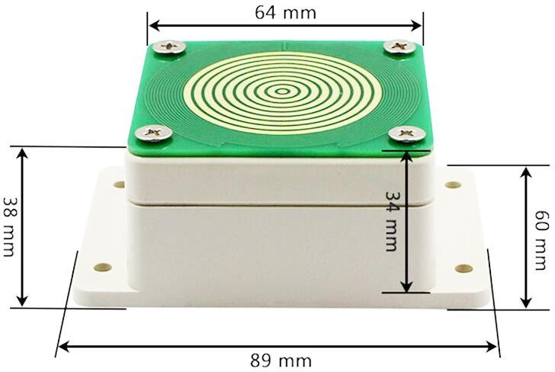

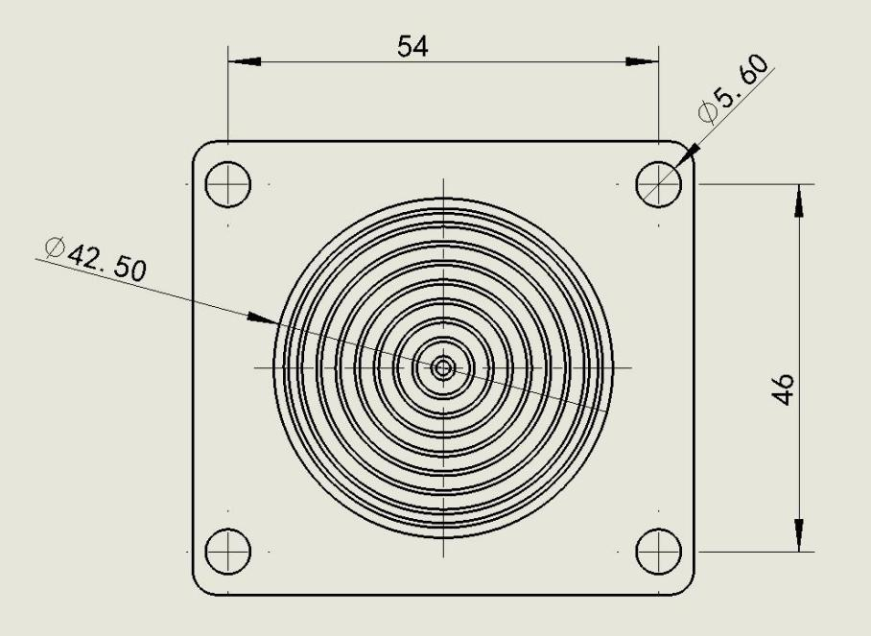

## System frame diagram

The product can also be combined with multiple sensors on a 485 bus, theoretically one bus

254 485 sensors, the other end connects the PLC, with the 485 interface chip, or to the computer using the USB turn 485, and performs configuration and testing using our sensor configuration tool (only one device when using the configuration software).

# Chapter 2. Hardware connection

* 1. **Check the equipment before installation**

Equipment List:

* One rain and snow sensor equipment
* 4 expansion plugs and 4 self-tapping screws
* Certificate of conformity, warranty card
  1. **Interface description**

Voltage supply input of 10~30V is available.During 485 signal wiring, note that two A/B lines cannot be reversed and conflicting address between multiple devices on the bus.

Switch measuring equipment is standard with 1 relay output, two outgoing lines (green, white) are normally open contacts.

* + 1. **Sensor wiring**

|  |  |  |
| --- | --- | --- |
| Name | Type 485 (-N01) | Switch Quantity Type (-R01) |
| Power supply | Power supply is positive (10~30V DC) (Brown) | |
| Negative Power Supply (black) | |
| Output | 485-A (Yellow) | Relay normally open contacts (white, green) |
| 485-B (Blue) |

* 1. **Installation mode**

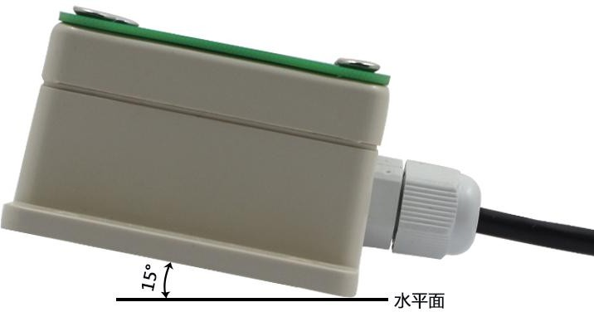

### (Installation angle)

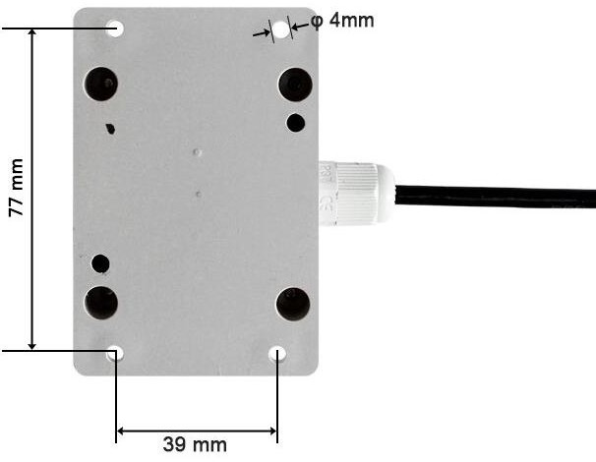

### (Installation size)

# Chapter 3. Configuration of software installation and use

We provide supporting "485 parameter configuration software" to read the sensor parameters by computer while flexibly modifying the device ID and address of the sensor.

Note that software automatically requires that there is only one sensor available on the 485 bus.

* 1. **Sensor access to the computer**

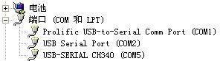After transferring the sensor through USB to 485 to the computer and supplying power, you can see the correct C O M port in the computer ("My Computer-Properties-Device Manager-Port").

Open the package, select Debug Software- - -485 Parameter Configuration Software, and find it open.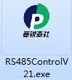

If no COM port is found in Device Manager, it means you do not install USB turn 485

Driver (available in the package) or not installed correctly, please contact the technician for assistance.

* 1. **Use of the sensor monitoring software**

The configuration interface, as shown in the figure, shall first obtain the serial slogan according to the method and select section 3.1

Serial port.

, Click on the test baud rate of the software, the software will test the baud rate and address of the current device, the default baud rate is 4800bit/s and the default address is 0x01.

, Modify the address and baud rate as per the usage needs, while checking the current functional status of the device.

. If the test is unsuccessful, recheck the equipment wiring and 485 drive installation.

* 1. **Communication basic parameters**

# Chapter 4. Communication Agreement

|  |  |
| --- | --- |
| Cocoding | 8-bit binary |
| Data bit | 8 bits |
| Parity check bit | None |
| Stop the bit | 1-bit is available |
| Error check | CRC (redundant cycle code) |
| The Porter rate | 2400bit/s, 4800bit/s, 9600 bit/s can be set, the factory default is 4800bit/s |

* 1. **Data frame format definition**

Use the Modbus-RTU communication protocol in the following format: the time of the initial structure ≥ 4 bytes

Address code = 1-byte function code = 1-byte data zone = N bytes

Error checking the = 16-bit CRC code end structure ≥ 4 bytes

Address code: The address of the transmitter, unique in the communication network (factory default 0x01).

Function code: the command issued by the host, the transmitter only uses function code 0x03(to read register data).

Data area: the data area is the specific communication data, note the 16bits data high byte in front!

CRC code: a two-byte check code.

Host inquiry frame structure:

|  |  |  |  |  |  |
| --- | --- | --- | --- | --- | --- |
| Address code | Function code | Register start address | Register length | Low check code | Check the code high level |
| 1 Bytes | 1 Bytes | 2 bytes | 2 bytes | 1 Bytes | 1 Bytes |

slave response frame structure:

|  |  |  |  |  |  |  |
| --- | --- | --- | --- | --- | --- | --- |
| Address code | Function code | Number of valid bytes | Data Area 1 | Second data area | N Data Zone | Check the code |
| 1 Bytes | 1 Bytes | 1 Bytes | 2 bytes | 2 bytes | 2 bytes | 2 bytes |

* 1. **Register address**

|  |  |  |  |  |  |  |
| --- | --- | --- | --- | --- | --- | --- |
| Register  Address | PLC or configuration  Address | Content | Operation | Function code | Default value | Scope |
| 0000H | 40001 | Real-time rain and snow state | Read-only | 03 | 0 | 0 or 1 |
| 0031H | 40050 | Lower temperature heating limit | Read / Write. | 03/06 | 15℃ | -30~70℃ |
| 0032H | 40051 | Heating temperature return. | Read / Write | 03/06 | 25℃ | 0~70℃ |
| 0033H | 40052 | Current alarm and return delay | Read / Write | 03/06 | 1s | 0~60000s |
| 0034H | 40053 | Current sensitivity | Read / Write | 03/06 | 800 | 500~3500 |

* 1. **Communication protocol examples and interpretation**

**ample: 1) Read the rain and snow status inquiry frame of the device address 0x01:**

|  |  |  |  |  |  |
| --- | --- | --- | --- | --- | --- |
| Address code | Function code | Start address. | Data length | Low check code | Check the code high level |
| 0x01 | 0x03 | 0x00 0x00 | 0x00 0x01 | 0x84 | 0x0A |

Response frame: the response with normal rain and snow state

|  |  |  |  |  |  |
| --- | --- | --- | --- | --- | --- |
| Address code | Function code | Returns the number of valid bytes | Data zone | Low check code | Check the code high level |
| 0x01 | 0x03 | 0x02 | 0x00 0x00 | 0xB8 | 0x44 |

**Ex**

Rain and snow status description:

|  |  |
| --- | --- |
| Rain and snow status code | Rain and snow state |
| 0x00 | Normal. |
| 0x01 | Alarm alarm. |

### Read the alarm reset delay inquiry frame of the device address 0x01:

|  |  |  |  |  |  |
| --- | --- | --- | --- | --- | --- |
| Address code. | Function code. | Start address. | Data length. | Low check code. | Check the code high level. |
| 0x01 | 0x03 | 0x00 0x33 | 0x00 0x01 | 0x74 | 0x05 |

Response frame: The current alarm reset delay is 1 second.

|  |  |  |  |  |  |
| --- | --- | --- | --- | --- | --- |
| Address code. | Function code. | Returns the number of valid bytes. | Data zone. | Low check code. | Check the code high level. |
| 0x01 | 0x03 | 0x02 | 0x00 0x01 | 0x79 | 0x84 |

### Set the alarm reset delay (10 seconds for example) for device address 0x01:

|  |  |  |  |  |  |
| --- | --- | --- | --- | --- | --- |
| Address code | Function code. | Write to the address | Data zone | Low check code | Check the code high level |
| 0x01 | 0x06 | 0x00 0x33 | 0x00 0x0A | 0xF9 | 0xC2 |

Response frame: The current alarm reset delay is 10 seconds

|  |  |  |  |  |  |
| --- | --- | --- | --- | --- | --- |
| Address code | Function code | Write to the address | Data zone | Low check code | Check the code high level. |
| 0x01 | 0x06 | 0x00 0x33 | 0x00 0x0A | 0xF9 | 0xC2 |

### Description of the alarm reset delay setting

If this value is 10S,, if the duration of rain and snow detected is more than 10S, the equipment thinks that the equipment detects rain and snow and output the alarm state. If the detected duration is less than 10S, the equipment thinks that no rain and snow is detected; similarly when the rain and snow return to normal state

Default value: 1 second

Range: 0~60000 seconds

### Read the current sensitivity inquiry frame for the device address 0x01:

|  |  |  |  |  |  |
| --- | --- | --- | --- | --- | --- |
| Address code. | Function code. | Start address. | Data length. | Low check code. | Check the code high level. |
| 0x01 | 0x03 | 0x00 0x34 | 0x00 0x01 | 0xC5 | 0xC4 |

Response frame: The current alarm reset delay is 800 seconds.

|  |  |  |  |  |  |
| --- | --- | --- | --- | --- | --- |
| Address code. | Function code. | Returns the number of valid bytes. | Data zone. | Low check code. | Check the code high level. |
| 0x01 | 0x03 | 0x02 | 0x03 0x20 | 0xB9 | 0x6C |

### Set the current sensitivity of the device address 0x01 (for example, 1500) inquiry frame:

|  |  |  |  |  |  |
| --- | --- | --- | --- | --- | --- |
| Address code. | Function code. | Write to the address. | Data zone | Low check code | Check the code high level |
| 0x01 | 0x06 | 0x00 0x34 | 0x05 0xDC | 0xCA | 0xAD |

Response frame: the current sensitivity bit is 1500

|  |  |  |  |  |  |
| --- | --- | --- | --- | --- | --- |
| Address code | Function code. | Write to the address. | Data zone | Low check code | Check the code high level |
| 0x01 | 0x06 | 0x00 0x34 | 0x05 0xDC | 0xCA | 0xAD |

### Sensitivity setting description.

Sensitivity value is inversely proportional to the actual sensitivity, and the larger the setting value, the less sensitive the equipment detection, and the smaller the sensitivity value, the more sensitive the equipment detection. However, it should be noted that the sensitivity value is too small, which is easy to cause false alarm, and it is recommended to use the factory default value.

Default value: 800.

Range: 500-3500.

# Chapter 5: FAQs and solutions.

**No possible cause of an output or an output error:**

", The computer has a COM port, and the selected port is incorrect.

, Porter rate error.

The, 485 bus is disconnected, or the A, B line is reversed.

With too much equipment or long wiring, power supply shall be provided nearby, with 485 enhancer and 120 Ω terminal resistance.

, USB turn 485 drive is not installed or damaged.

1. Damage to the equipment.